

Hoschton Office:
5415 Thompson Mill Road, Suite A
Hoschton, GA 30548
770-967-8462
www.wilsonbraces.com

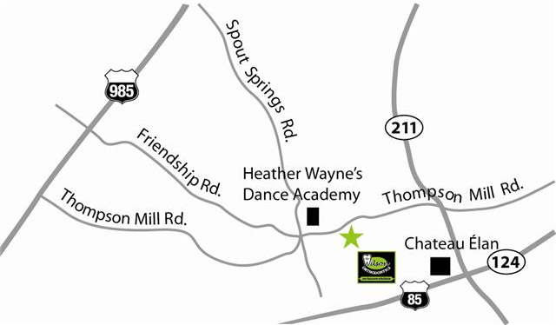
Note: Map quest directions are not accurate

Traveling I-85N: Exit on Hwy 211 (Chateau Elan Exit) and turn left. Go approximately 1.5 miles to Thompson Mill Rd and turn left (new traffic light at Mulberry Park). Our office will be on the left after traveling approximately 3 miles (you will pass Reunion Subdivision on the right). If you come to the 4 way stop sign at Spout Springs Rd, you have gone too far.
Traveling I-85S: Exit on Hwy 211 (Chateau Elan Exit) and turn right. Go approximately 1.5 miles to Thompson Mill Rd and turn left (new traffic light at Mulberry Park). Our office will be on the left after traveling approximately 3 miles (you will pass Reunion Subdivision on the right). If you come to the 4 way stop sign at Spout Springs Rd, you have gone too far.
Traveling I-985N: Exit off of Spout Springs Road and turn right. Go Approximately 5 miles to the one and only stop sign that you will come to and turn left (Thompson Mill Road). We are 0.3 miles on the right.
Traveling I-985S: Exit off of Spout Springs Road and turn leftt. Go Approximately 5 miles to the one and only stop sign that you will come to and turn left (Thompson Mill Road). We are 0.3 miles on the right.

