

Gainesville Office:
1220 Sherwood Park Drive
Gainesville, GA 30506
770-536-0882
www.wilsonbraces.com
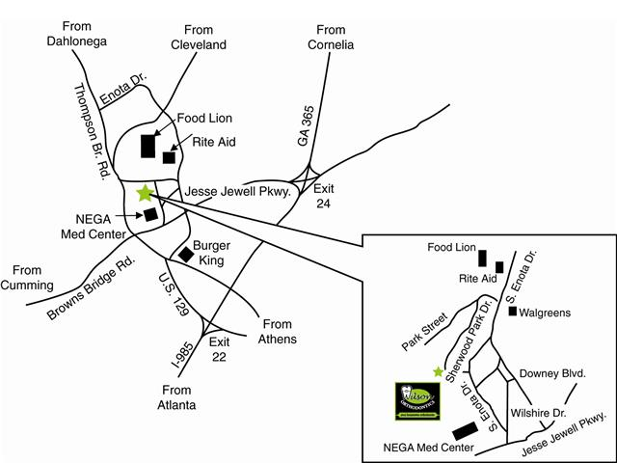

Note: Map quest directions are accurate for the Gainesville Office…Click on “To here” in the Google map provided on the Office Locations/Maps section of our webpage for door to door directions that you can print.
You may also print this map for further reference.

